**What is Prometheus ?**

* Prometheus is a open source Linux Server Monitoring tool mainly used for metrics monitoring, event monitoring, alert management, etc.
* Prometheus has changed the way of monitoring systems and that is why it has become the Top-Level project of Cloud Native Computing Foundation (CNCF).
* Prometheus uses a powerful query language i.e. “PromQL”.
* In Prometheus tabs are on and handles hundreds of services and microservices.
* Prometheus use multiple modes used for graphing and dashboarding support.
* <https://www.youtube.com/watch?v=DuYnPOq4D6w&list=PLdsu0umqbb8NxUs8r8BIUe9-PhcoZyojA>
* <https://github.com/Dakshjain1/Kubernetes/tree/master/Prometheus-on-Kubernetes>
* <https://github.com/Dakshjain1/DevOps_Project_Files>

**Prometheus Architecture**

Prometheus architecture includes three main components :

* The prometheus server itself : which collect metrics and answer to queries via API
* A pushgateway : to expose metrics for ephemeral and short jobs
* An alertmanager : to enable the alerts publication as name suggests

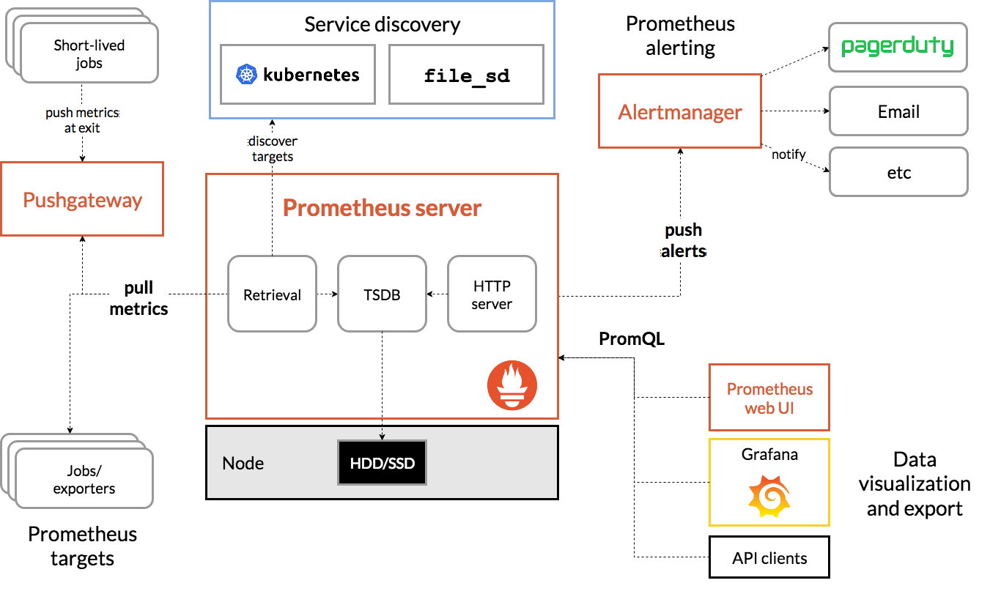

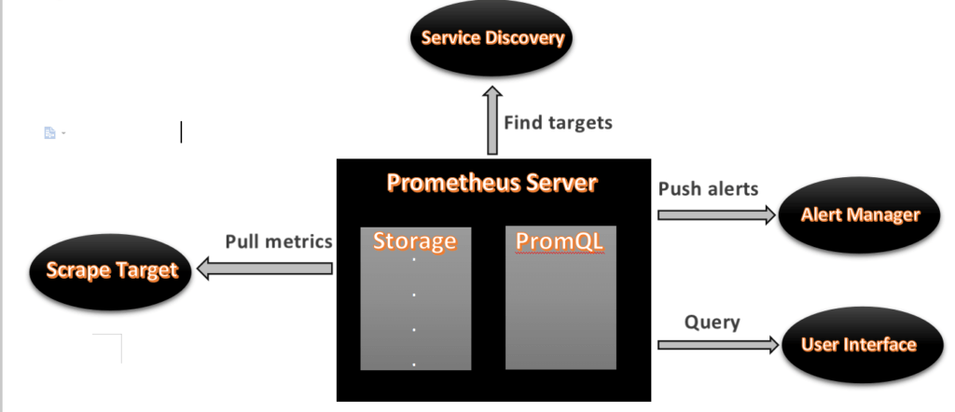

* As above we can see an architecture of Prometheus monitoring tool.
* We made a basic design to understand it easily for you people.

Now lets understand the Prometheus components one-by-one

**Prometheus Components**

**1. Prometheus Server**

* Prometheus server is a first component of Prometheus architecture.
* Prometheus server is a core of Prometheus architecture which is divided into several parts like Storage, PromQL, HTTP server, etc.
* In Prometheus server data is scraped from the target nodes and then stored int the database.

**1.a. Storage**

* Storage in Prometheus server has a local on disk storge.
* Prometheus has many interfaces that allow integrating with remote storage systems.

**1.b. PromQL**

* Prometheus uses its own query language i.e. PromQL which is very powerful querying language.
* PromQL allows the user to select and aggregate the data.

**2. Service Discovery**

* Next and very important component of Prometheus Server is the Service Discovery.
* With the help of Service discovery the services are identified which are need to scraped.
* To Pull metrics, identification of services and finding the targets are compulsory needed.
* Through Service discovery we monitor the entities and can also locate its targets.

**3. Scrape Target**

* Once the services are identified and the targets are ready then we can pull metrics from it and can scrape the target.
* We can export the data of end point using node exporters.
* Once the metrics or other data is pulled, Prometheus stores it in a local storage.

**4. Alert Manager**

* Alert Manager handles the alerts which may occurs during the session.
* Alert manager handles all the alerts which are sent by Prometheus server.
* Alert manager is one of the very useful component of Prometheus tool.
* If in case any big error or any issue occurs, alert manager manage those alerts and contact with human via E-mail, Text Messages, On-call, or any other chat application service.

**5. User Interface**

* User interface is also a important component as it builds a bridge between the user and the system.
* In Prometheus, user interface are note that much user friendly and can be used till graph queries.
* For good exclusive dashboards Prometheus works together with Grafana (visualization tool).
* Using Grafana over Prometheus to visualize properly we can use custom dashboards.
* Grafana dashboards displays via pie charts, line charts, tables, good data graphs of CPU usage, RAM utilization, network load, etc with indicators.
* Grafana supports and run with Prometheus by querying language i.e. PromQL.
* To fetch data from Prometheus and to display the results on Grafana dashboards PromQL is used.

**What is Grafana ?**

* Grafana is a free and open source visualization tool mostly used with Prometheus to which monitor metrics.
* Grafana provides various dashboards, charts, graphs, alerts for the particular data source.
* Grafana allows us to query, visualize, explore metrics and set alerts for the data source which can be a system, server, nodes, cluster, etc.
* We can also create our own dynamic dashboard for visualization and monitoring.
* We can save the dashboard and can even share with our team members which is one of the main advantage of Grafana.

**What is Node Exporter ?**

* Node exporter is one of the Prometheus exporters which is used to expose servers or system OS metrics.
* With the help of Node exporter we can expose various resources of the system like RAM, CPU utilization, Memory Utilization, disk space.
* Node exporter runs as a system service which gathers the metrics of your system and that gathered metrics is displayed with the help of Grafana visualization tool.

**Prerequisites**

* Ubuntu with 20.04 Version
* Root user account with **sudo** privilege.
* Prometheus system user and group.
* Sufficient storage on your system and good internet connectivity.
* Ports Required- **9090 (Prometheus), 3000 (Grafana), 9100 (Node Exporter)**

We will update the system repository index by using the following command.

sudo apt update -y

switch to root user

sudo su -

Export the release of Prometheus

export RELEASE="2.2.1"

**#1. Creating Prometheus System Users and Directory**

We will have to create a Prometheus user named Prometheus and a Prometheus directory named as Prometheus.

Using below commands we can create a user and directory.

sudo useradd --no-create-home --shell /bin/false prometheus

sudo useradd --no-create-home --shell /bin/false node_exporter

sudo mkdir /etc/prometheus

 sudo mkdir /var/lib/prometheus

**#2. Update Prometheus user**

As user groups and directories are created successfully which store the Prometheus data and files.

Now we will have to update the group and user ownership on the newly created directories.

By using the below command we update the ownership.

sudo chown prometheus:prometheus /etc/prometheus

sudo chown prometheus:prometheus /var/lib/prometheus

**#3. Download Prometheus Binary File**

Now we will download the latest version of Prometheus. We can copy the download link as per our Operating System from [Prometheus download page](https://prometheus.io/download/)

Using below command we can download Prometheus, here we are downloading Prometheus 2.26 version, you use above link to download specific version.

Navigate to **/opt** directory

 cd /opt/

Download the Prometheus setup using wget

wget https://github.com/prometheus/prometheus/releases/download/v2.26.0/prometheus-2.26.0.linux-amd64.tar.gz

Now we have successfully downloaded the Prometheus file and now we will extract that file.

**#4.Install Prometheus and Grafana on Ubuntu 20.04 LTS**

We can use sha256sum command line to generate a checksum of the Prometheus downloaded file.

We will also extract the downloaded file using the **tar** command.

sha256sum prometheus-2.26.0.linux-amd64.tar.gz

**Output:**

f1f2eeabbf7822572dce67565dc96ffaa2dd1897dd1d844562552b11123f151a prometheus-2.26.0.linux-amd64.tar.gz

We have verify that the output from above command with checksum matches the sha256sum checksum which is on official Prometheus download page.

It will ensure that our downloaded file is not a corrupted file.

Now we will extract the Prometheus setup file using the following commands.

tar -xvf prometheus-2.26.0.linux-amd64.tar.gz

navigate to prometheus extracted folder

cd prometheus-2.26.0.linux-amd64

To check list of setup files

ls

**#5. Copy Prometheus Binary files**

Now we have two libraries in our directory i.e. Prometheus and promtool. We will have to copy that both libraries to our /usr/local/bin directory.

By following below commands we will perform the copy operation.

sudo cp /opt/prometheus-2.26.0.linux-amd64/prometheus /usr/local/bin/

sudo cp /opt/prometheus-2.26.0.linux-amd64/promtool /usr/local/bin/

**#6. Update Prometheus user ownership on Binaries**

Now we will update the user and group ownership on the binaries of Prometheus.

Using following commands we will update the user and group ownership.

sudo chown prometheus:prometheus /usr/local/bin/prometheus

sudo chown prometheus:prometheus /usr/local/bin/promtool

**#7. Copy Prometheus Console Libraries**

We will need to copy the console and console_libraries directories to /etc/Prometheus/.

Use below commands to copy console and console_libraries.

sudo cp -r /opt/prometheus-2.26.0.linux-amd64/consoles /etc/prometheus

sudo cp -r /opt/prometheus-2.26.0.linux-amd64/console_libraries /etc/prometheus

sudo cp -r /opt/prometheus-2.26.0.linux-amd64/prometheus.yml /etc/prometheus

**#8. Update Prometheus ownership on Directories**

Now we will update the user and group ownership on the directories  to Prometheus user using -R.

By executing this commands ownership is set on is ensured. Execute the following commands.

sudo chown -R prometheus:prometheus /etc/prometheus/consoles

sudo chown -R prometheus:prometheus /etc/prometheus/console_libraries

 sudo chown -R prometheus:prometheus /etc/prometheus/prometheus.yml

**#9. Check Prometheus Version**

Now the Prometheus is successfully installed on our system. We will check the version of Prometheus and promtool to configure it.

Follow the commands to verify prometheus version.

prometheus --version

promtool --version

**Output:**

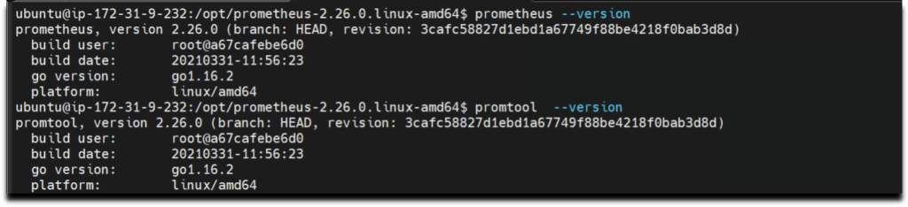

**#10. Prometheus configuration file**

We have already copied **/opt/prometheus-2.26.0.linux-amd64/prometheus.yml** file **/etc/prometheus** directory, verify if it present and should look like below and modify it as per your requirement.

cat /etc/prometheus/prometheus.yml

# my global config

global:

scrape_interval: 15s # Set the scrape interval to every 15 seconds. Default is every 1 minute.

evaluation_interval: 15s # Evaluate rules every 15 seconds. The default is every 1 minute.

# scrape_timeout is set to the global default (10s).

# Alertmanager configuration

alerting:

alertmanagers:

- static_configs:

- targets:

# - alertmanager:9093

# Load rules once and periodically evaluate them according to the global 'evaluation_interval'.

rule_files:

# - "first_rules.yml"

# - "second_rules.yml"

# A scrape configuration containing exactly one endpoint to scrape:

# Here it's Prometheus itself.

scrape_configs:

# The job name is added as a label `job=<job_name>` to any timeseries scraped from this config.

- job_name: 'prometheus'

# metrics_path defaults to '/metrics'

# scheme defaults to 'http'.

static_configs:

- targets: ['localhost:9090']

**#11. Creating Prometheus Systemd file**

To run Prometheus as service we have to setting up prometheus, We will provide a path for both configuration file and data directory. We will start it with the Prometheus user using the following command.

sudo -u prometheus /usr/local/bin/prometheus \

--config.file /etc/prometheus/prometheus.yml \

--storage.tsdb.path /var/lib/prometheus/ \

--web.console.templates=/etc/prometheus/consoles \

--web.console.libraries=/etc/prometheus/console_libraries

Now we will create a system service file in **/etc/systemd/system** location.

sudo nano /etc/systemd/system/prometheus.service

After creating file successfully, copy the below files and it to the newly created file. /etc/systemd/system/prometheus.service

[Unit]

Description=Prometheus

Wants=network-online.target

After=network-online.target

[Service]

User=prometheus

Group=prometheus

Type=simple

ExecStart=/usr/local/bin/prometheus \

--config.file /etc/prometheus/prometheus.yml \

--storage.tsdb.path /var/lib/prometheus/ \

--web.console.templates=/etc/prometheus/consoles \

--web.console.libraries=/etc/prometheus/console_libraries

[Install]

WantedBy=multi-user.target

After adding the program save the file with **Ctrl+O** and exit with **Ctrl+X**.

To use the newly created service we will have to reload the daemon services, Use the below command to reload daemon services.

sudo systemctl daemon-reload

start and enable prometheus service using below commands

sudo systemctl start prometheus

sudo systemctl enable prometheus

We will check the Prometheus status weather it is running or not

sudo systemctl status prometheus

**Output :-**

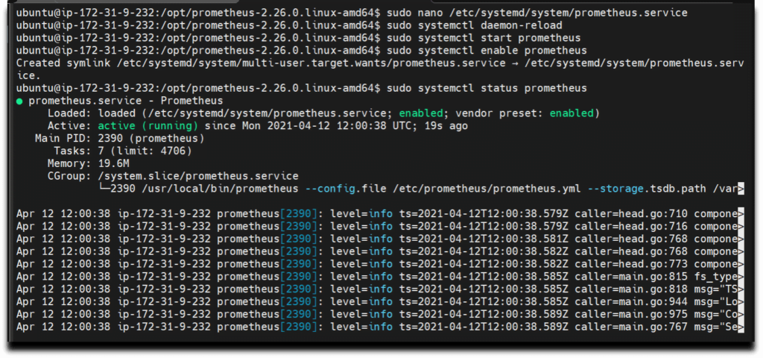

Prometheus installation and configuration is set up, We can see status Active:  active(running)

**#12. Accessing Prometheus**

Now as Prometheus installation and configuration is set up and it is ready to use we can access  its services via web interface.Also check weather port 9090 is UP in firewall.

Use below command to enable prometheus service in firewall

 sudo ufw allow 9090/tcp

Now Prometheus service is ready to run and we can access it from any web browser.

http://server-IP-or-Hostname:9090.

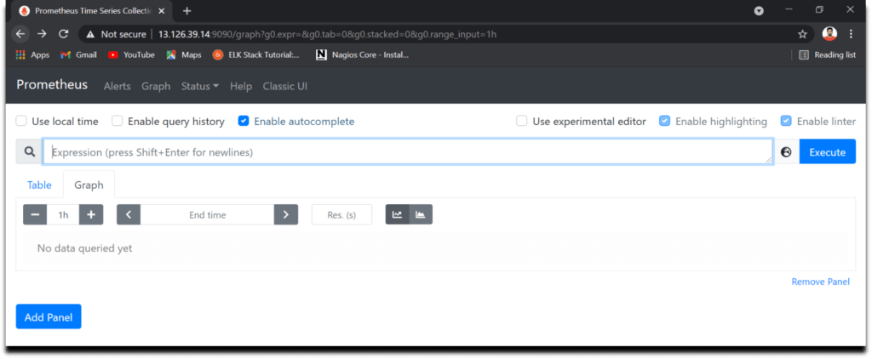

As we can see the Prometheus dashboards, we can also check the target.As we can observe Current state is UP and we can also see the last scrape.

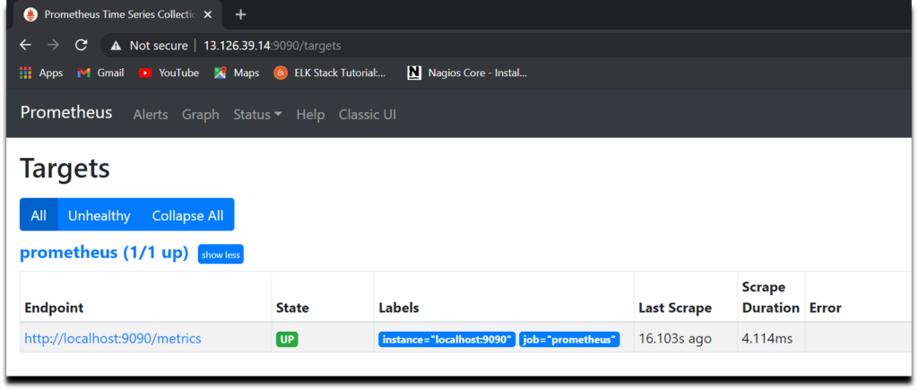

Here are some snapshots of Prometheus dashboards and graphs.

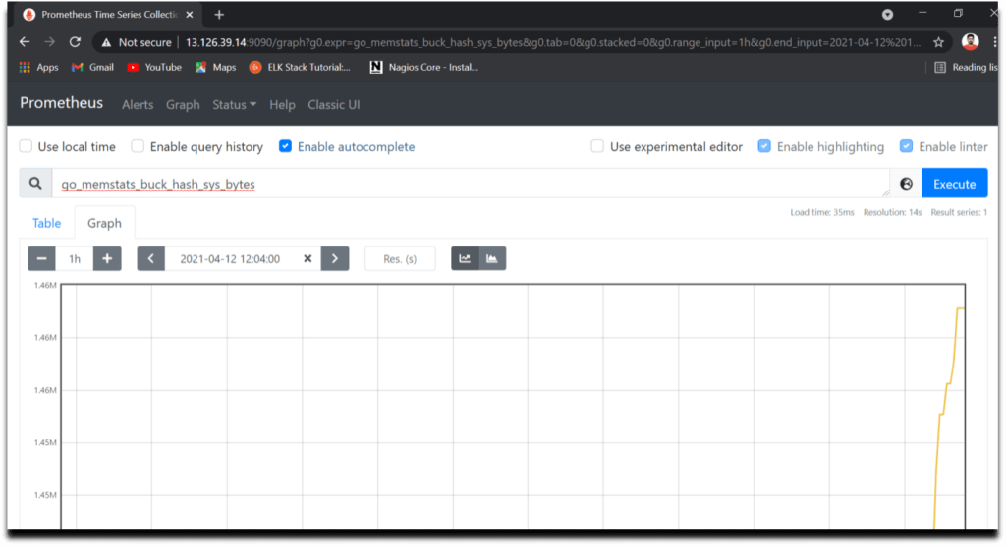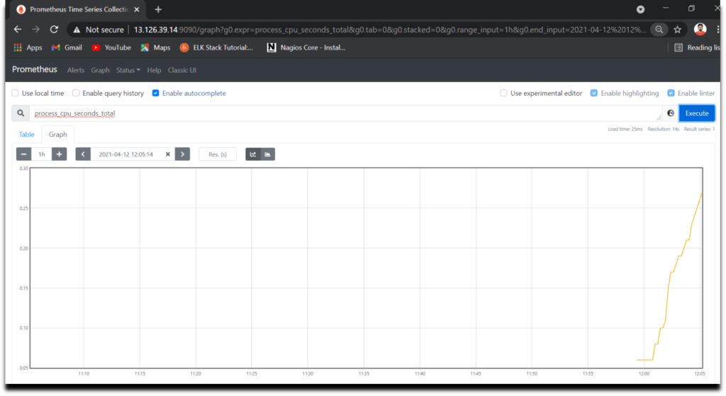

**#13.Install Grafana on Ubuntu 20.04 LTS using APT**

Now lets Install Grafana for wonderful dashboards and data visualization for monitoring systems, servers, services, etc

We can install grafana on Ubuntu either by downloading .deb package from [Grafana Download page](https://grafana.com/docs/grafana/latest/installation/debian/) or using APT which is more easier.

Add the Grafana GPG key in Ubuntu using wget

wget -q -O - https://packages.grafana.com/gpg.key | sudo apt-key add –

Now add the Grafana repository in Ubuntu using APT

echo "deb https://packages.grafana.com/oss/deb stable main" | sudo tee -a /etc/apt/sources.list.d/grafana.list

update the system packages to take effect

sudo apt-get update

Now lets Install Grafana using below command

sudo apt-get install grafana

Now start the Grafana service using below command

sudo systemctl start grafana-server

Verify the Grafana Service Status using below command

sudo systemctl status grafana-server

Now finally enable the Grafana service which will automatically start the Grafana on boot

sudo systemctl enable grafana-server.service

To access Grafana Dashboard open your favorite browser, type server IP or Name followed by grafana default port 3000.

http://your_ip:3000

Here you can see Login page of Grafana now you will have to login with below Grafana default UserName and Password.

Username – **admin**

Password – **admin**



It is always a good practice to change your login credentials.

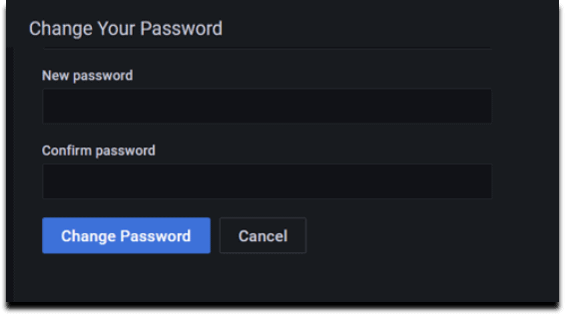

Provide your New Password and click on **Change Password**

Now here you can see Home Dashboard page of Grafana

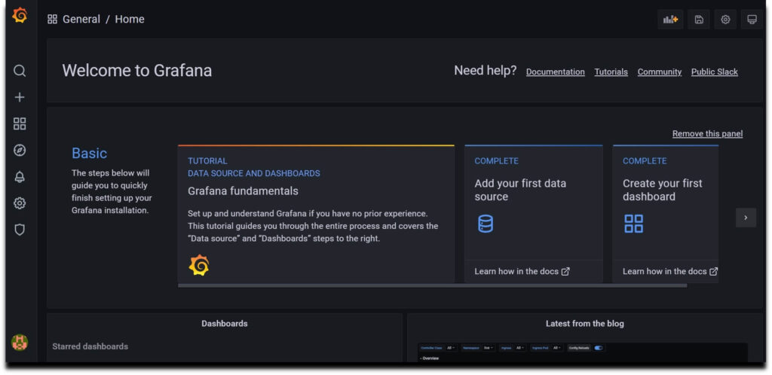

**#14. Configure Prometheus as Grafana DataSource**

Once you logged into Grafana Now first Navigate to **Settings Icon ->> Configuration ->> data sources**

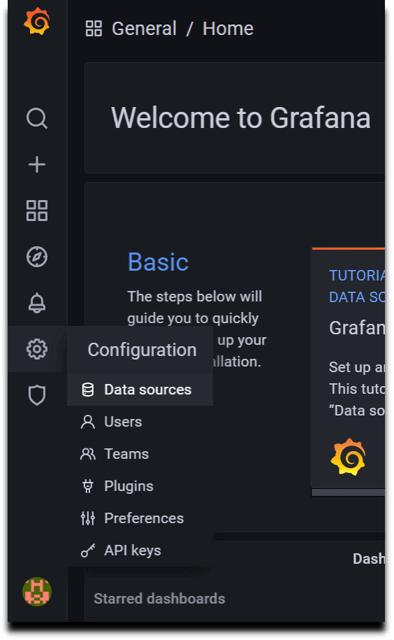

Now lets click on **Add Data sources**and select **Prometheus**

* 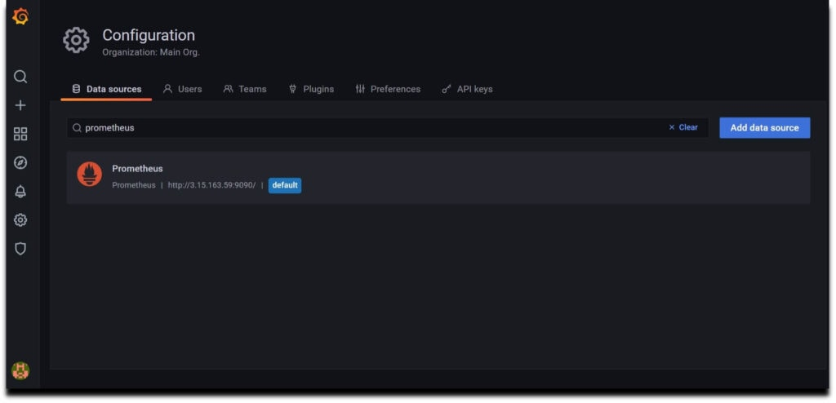

Now configure Prometheus data source by providing Prometheus URL

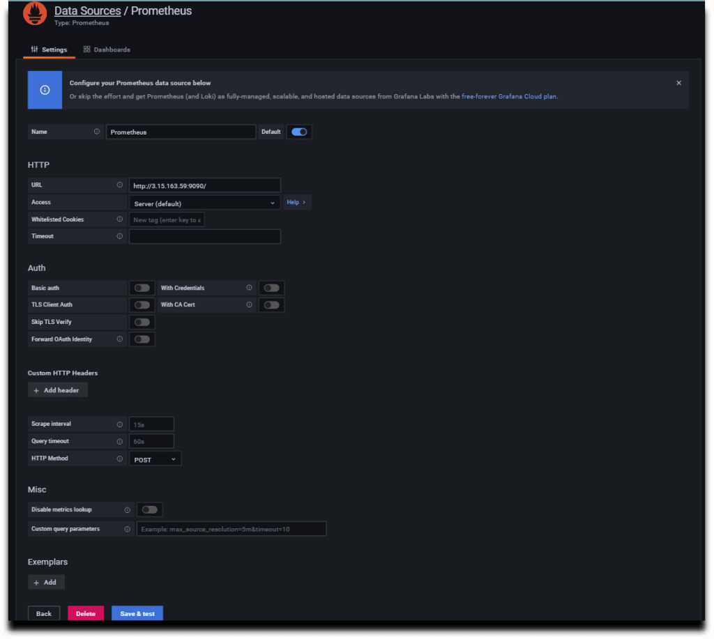

As per your requirement you can do other changes or you can also keep remaining configuration as default.

Now click on **Save & test**so it will prompt a message**Data Source is working**.

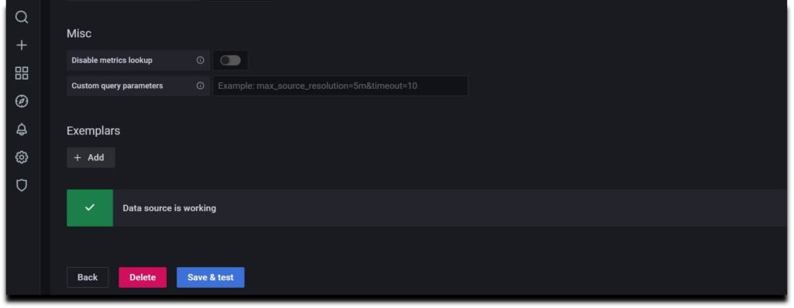

**#15. Install Node Exporter on Ubuntu 20.04 LTS**

Node Exporter collects the metrics of your system such as Memory usage, CPU usage, RAM, disk space, etc.

To install Node Exporter first navigate to [Prometheus official download page](https://prometheus.io/download/), Scroll down and you will get **node_exporter** section and then select Linux OS for amd64.

Now right click on node exporter and copy link address

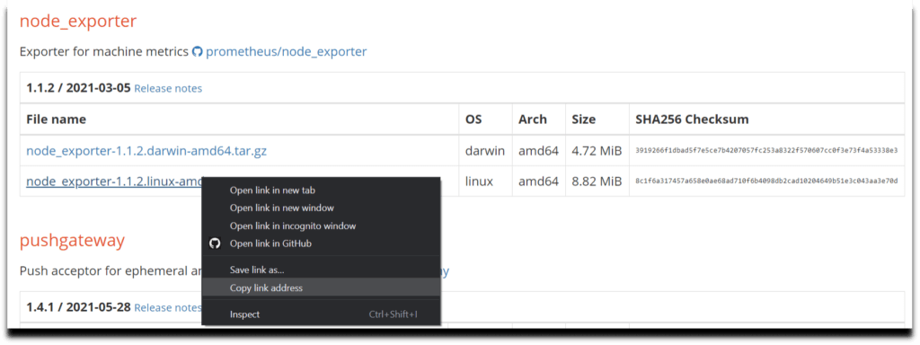

Now lets run the copied URL with **wget** command

wget https://github.com/prometheus/node_exporter/releases/download/v1.2.0/node_exporter-1.2.0.linux-amd64.tar.gz

Unzip the downloaded the file using below command

sudo tar xvzf node_exporter-1.2.0.linux-amd64.tar.gz

Now do **ls**and your can see node_exporter binary file.

Go to that file and move this file to your /usr/local/bin directory using below command

cd node_exporter-1.2.0.linux-amd64

sudo cp node_exporter /usr/local/bin

As early at the time of Prometheus installation we have created node_exporter user and also updated the ownership permission so we will not repeat it again

**#16. Creating Node Exporter Systemd service**

Now lets create a node_exporter service in /lib/systemd/system directory named node_exporter.service using below commands

cd /lib/systemd/system

sudo nano node_exporter.service

Paste the below content in your service file

[Unit]

Description=Node Exporter

Wants=network-online.target

After=network-online.target

[Service]

Type=simple

User=node_exporter

Group=node_exporter

ExecStart=/usr/local/bin/node_exporter \

— collector.mountstats \

— collector.logind \

— collector.processes \

— collector.ntp \

— collector.systemd \

— collector.tcpstat \

— collector.wifi

Restart=always

RestartSec=10s

[Install]

WantedBy=multi-user.target

Now lets start and enable the node_exporter service using below commands

sudo systemctl daemon-reload

 sudo systemctl enable node_exporter

 sudo systemctl start node_exporter

sudo systemctl status node_exporter

We have covered How to Install Prometheus and Grafana on Ubuntu 20.04 LTS with Node Exporter.

**#17. Configure the Node Exporter as a Prometheus target**

Now to scrape the node_exporter lets instruct the Prometheus by making a minor change in prometheus.yml file

So go to etc/prometheus and open prometheus.yml

cd /etc/prometheus

sudo nano prometheus.yml

Now in **static_configs**in your configuration file replace the target line with the below one

- targets: [‘localhost:9090’, ‘localhost:9100’]

Now restart the Prometheus Service

sudo systemctl restart prometheus

Hit the URL in your web browser to check weather our target is successfully scraped by Prometheus or not

https://localhost:9100/targets

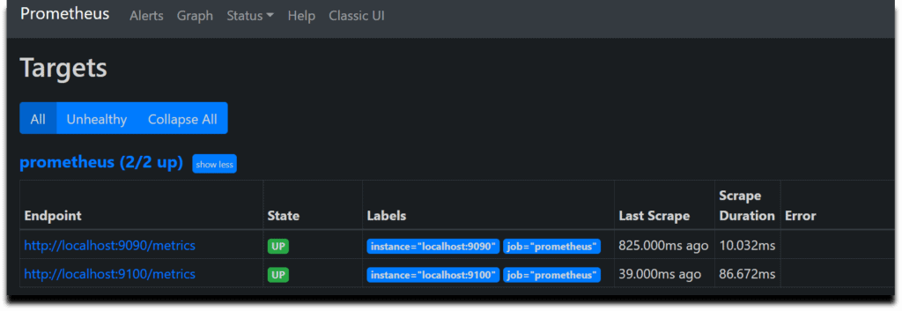

We have covered How to Install Prometheus and Grafana on Ubuntu 20.04 LTS with Node Exporter.

**#18. Creating Grafana Dashboard to Monitor Linux Server**

Now lets build a dashboard in Grafana so then it will able to reflect the metrics of the Linux system.

So we will use 14513 to import Grafana.com, Lets come to Grafana Home page and you can see a **“+”** icon. Click on that and select **“Import”**

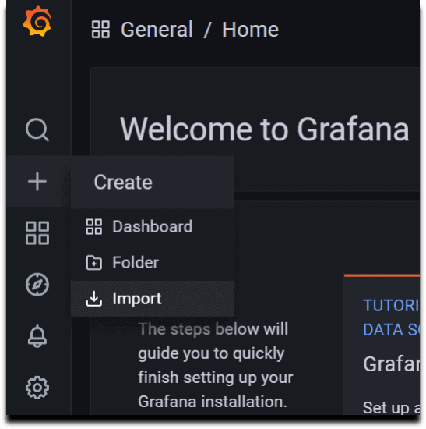

Now provide the Grafana.com Dashboard ID which is **14513**and click on **Load**

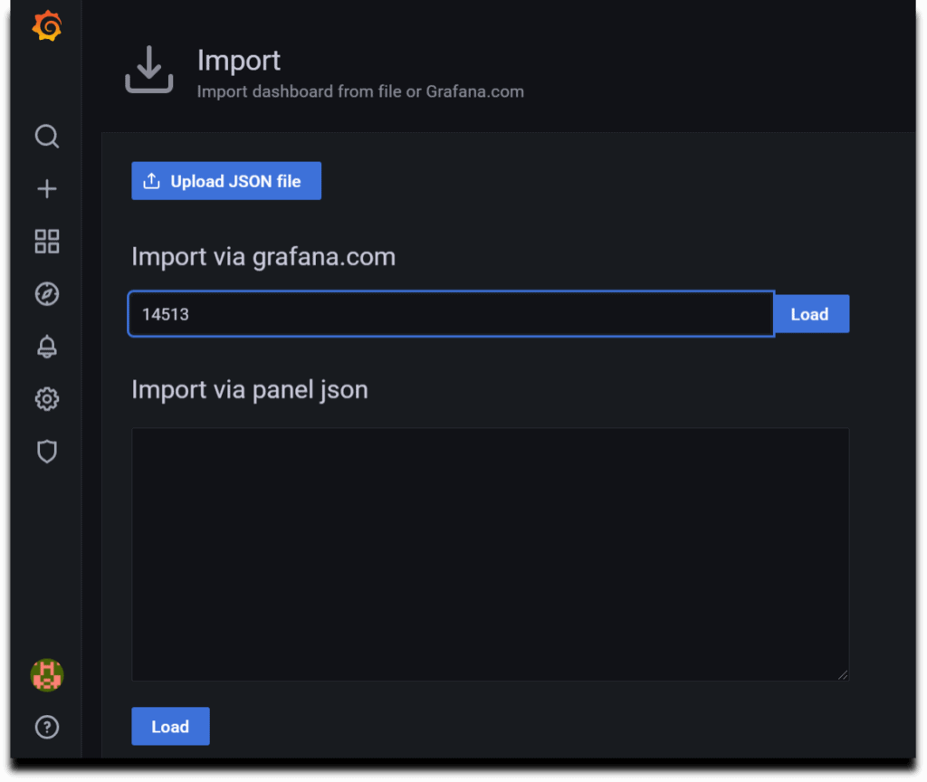

Now provide the name and select the Prometheus Datasource and click on **Import**.

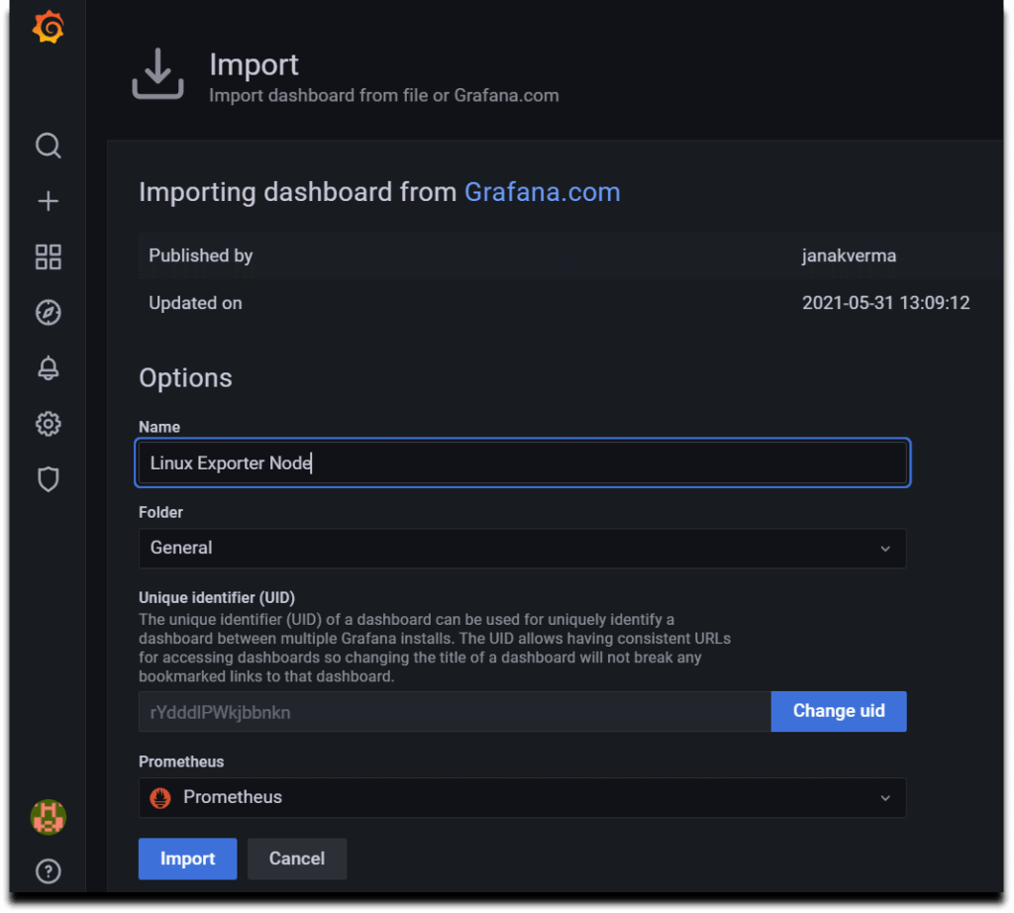

There you are done with the setup. Now your Dashboard is running up!.

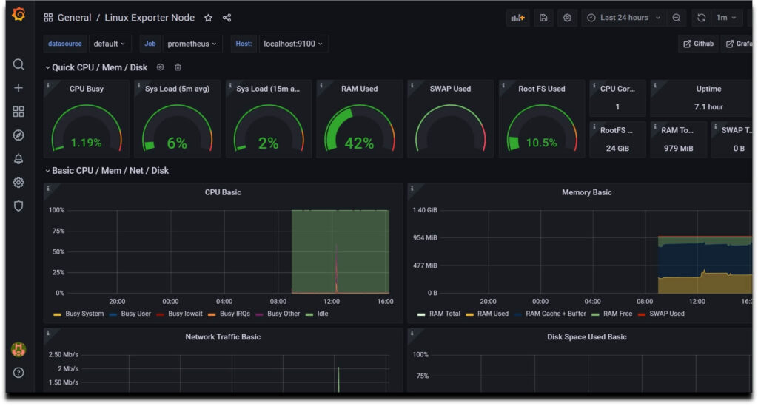

**Conclusion:**

We have covered How to Install Prometheus on Ubuntu 20.04 LTS, Monitoring Linux server with Prometheus and Grafana with Node Exporter

**Related Articles:**

* [Kubernetes cluster Monitoring with Prometheus and Grafana.](https://www.fosstechnix.com/kubernetes-cluster-monitoring-with-prometheus-and-grafana/)